*HOLY TRINITY NEWS*

***July 2024* VOLUME 59 NO. 07**



**HOLY TRINITY LUTHERAN CHURCH 610-826-2524**

**502 LAFAYETTE AVENUE, PALMERTON, PA 18071**

E-MAIL htlcoppa@ptd.net

FACEBOOK facebook.com/HolyTrinityPalmerton

WEB PAGE www.HolyTrinityPalmerton.org

REV. MICHAEL FROST 570-620-8189

PASTor E-MAIL ADDRESS htpastor@ptd.net



COUNCIL MEETING CANCELED

**From the Pastor’s Desk – July 2024**

***“Christmas in July”***

***26In the sixth month the angel Gabriel was sent by God to a town in***

***Galilee called Nazareth, 27to a virgin engaged to a man whose name was Joseph,***

***of the house of David. The virgin’s name was Mary. 28And he came to her and***

***said, “Greetings, favored one! The Lord is with you.” 29But she was much***

***perplexed by his words and pondered what sort of greeting this might be.***

***30The angel said to her, “Do not be afraid, Mary, for you have found favor with God. 31And now, you will conceive in your womb and bear a son, and you will***

***name him Jesus. 32He will be great and will be called the Son of the Most High,***

***and the Lord God will give to him the throne of his ancestor David. 33He will***

***reign over the house of Jacob forever, and of his kingdom there will be no end.”***

***34Mary said to the angel, “How can this be, since I am a virgin?” 35The angel said***

***to her, “The Holy Spirit will come upon you, and the power of the Most High will overshadow you; therefore the child to be born will be holy; he will be called Son***

***of God.* (Luke 1:26-35 NRSV-U)**

I was reading something the other day that tried to make the case that Christianity has, in building a religion around Jesus, created something that Jesus himself never intended. Jim Palmer was a very successful Evangelical pastor but, after 20+ years in ministry, he walked away. These days it has become a bit of a thing – called deconstructing. He no longer believes. He seems to be trying to figure out what to do with Jesus apart from what he considers the trappings of Christianity. He wrote, *“In my view, Christianity royally messed up by putting Jesus on a pedestal and creating a religion in his name. By doing so, the Christian religion made Jesus unhuman – virgin birth, sinless perfection, God in the flesh, savior of the world, bodily raised from the grave into heaven.”*

What are we to make of such a thing? Apparently, he wants to be able to pick and choose those parts of the Jesus story that he likes, that make sense to him, that he believes are rational while rejecting the rest. He’s hardly the first person to attempt such a feat. Founding Father and third President Thomas Jefferson was a Rationalist. He rejected the supernatural aspects of the Christian religion and the story of Jesus. He compiled an account of the life and teachings of Jesus that eliminated the miracles and those other aspects of the story that he could not believe. Literally with razor and glue, he cut and pasted the parts he liked, the moral teachings and the narrative of the story, but left all references to miracles, to the Virgin Birth and the Resurrection on, as it were, the cutting room floor.

It seems important to me, then, that we should take a stand for the whole truth of the gospel. When some are declaring their rejection of the clear Word of God in the pages of Scripture, the Creeds, and the life and ministry of the Church, we need to be bold in affirming our faith and trust in all that God has done for us and for the world in Jesus, in his Incarnation, his life and ministry, and in his death and resurrection.

You have, undoubtedly, heard of “Christmas in July”. Well, let’s take this time to celebrate God’s gracious act in the Incarnation of Jesus – the Eternal Son of the Father from before the foundation of the world taking on our humanity so that we might

come to be reconciled in love to the God who created us, in whose image we are created. This Jesus, whose teachings Jim Palmer, Thomas Jefferson and others wish to hold up as exemplary, was not – is not merely a good moral teacher. This Jesus was not merely human, though indeed he was and is every bit as human as you and I. It is the clear witness of Scripture that Jesus has been, from the moment of his conception in the Virgin Mary, the Incarnate only-begotten Son of God. In the words of the Nicene Creed – ***“God from God, Light from Light, true God from true God, begotten, not made, of one Being with the Father.”***

What, you may ask, did Martin Luther believe about the Incarnation? In the Small Catechism, in his explanation to the second article of the creed, Luther wrote this: ***“I believe that Jesus Christ, true God, begotten of the Father from eternity, and also true man, born of the Virgin Mary, is my Lord.”*** Luther understood and accepted the truth that in Jesus we see both our own humanity and full divinity and that the two natures in Christ are necessary for the working out of our justification and salvation. He wrote this in order to explain the truth of the Incarnation: ***“We Christians should know that if God is not in the scale to give it weight, we, on our side, sink to the ground. I mean it this way: if it cannot be said that God died for us, but only a man, we are lost; but if God’s death and a dead God lie in the balance, His side goes down and ours goes up like a light and empty scale. Yet He can also readily go up again or leap out of the scale! But He could not sit on the scale unless He became a man like us, so that it could be called God’s dying, God’s martyrdom, God’s blood, and God’s death. For God in His own nature cannot die; but now that God and man are united in one person, it is called God’s death when the man dies who is one substance or one person with God.”*** On the Councils and the Church, quoted in the Formula of Concord:

Solid Declaration VIII:44, Concordia: The Lutheran Confessions,

McCain et al., Eds. (St. Louis: Concordia, 2005, 2006) pp. 588-89

So, on Sunday, July 21, we are going to celebrate these powerful realities, the truth of the Incarnation, with a Christmas in July worship service at both St. Matthew’s and at Holy Trinity. The Christmas readings and some of your favorite carols will help us lift up the whole witness of Scripture and the traditions of the faith that communicate to us the gifts of forgiveness, life and salvation in the Virgin birth, the life, death, and resurrection of Jesus. We hope you will join us.

Blessings to you and Peace in Jesus, the Incarnate Son of the Father

Pastor Mike

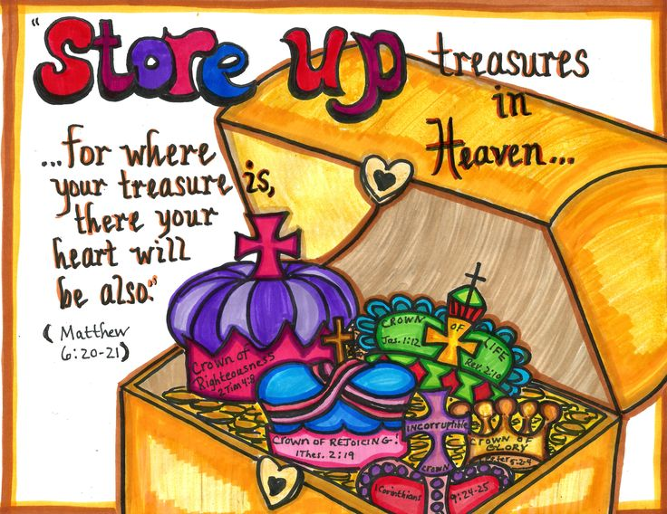

**HOLY TRINITY ACTION MINISTRY**

**THRIFT SHOP:**

**TUESDAY 9am-12:30pm**



***FINANCE & ATTENDANCE***

**ANNIVERSARIES**

July 03 Dennis & Gerry Dorshimer 59 years

July 04 Ray & Karen Talamantes 16 years

July 05 Robin & Shirley Suarez 49 years

July 16 David & Veronica Blocker 19 years

July 22 William & Brittany Zeky 07 year

July 24 Pastor Michael & Ginny Frost 25 years



***Happy Birthday!***

July 04 Brian Everett

July 04 Lizzie Reif

July 06 Sandra Benson

July 08 Vicky Holland

July 11 Gordon Walls

July 14 Garry James

July 14 Karen McIntosh

July 19 Sean Hamor

July 20 Robert Reinhart

July 23 Jason Pryce, Sr.

July 27 Jacqueline Grimley

July 27 Vanessa Zellers

July 28 Matthew Jahelka

July 30 Veronica Blocker

*NOTE: If we have omitted your birthday or anniversary, please let us know.*

|  |  |
| --- | --- |
| **May Monthly Envelope Offering:** | $ 7,691 |
| **May St. Matthews Pastoral Service** | $ 3,300 |
| **May Additional Income** | $ 1,046 |
| **May Monthly Expenses:** | $ 12,372 |
| **Attendance:** |  |
| **May 05, 2024** | 41 |
| **May 12, 2024** | 36 |
| **May 19, 2024** | 36 |
| **May 26, 2024** | 29 |
|  |  |
|  |  |

**COMMITTEE MEETINGS**

**NO JULY COUNCIL MEETING**



***COUNCIL MEMBERS***

**Terry Holland President**

**Jon Kistler Vice-President**

**Karen Talamantes Secretary**

**Larry Arner Treasurer**

**Jim Miller Asst. Treasurer**

**Steve Berger**

**Gerry Dorshimer**

**Scott Heinrich**

**Krissy Keblish**

**Ron Keblish**

**Eric Reif**

**Ray Talamantes**

**FINANCIAL PERSONNEL**

**Larry Arner Treasurer**

**Carol Heffelfinger Financial Sec.**

**WORSHIP SCHEDULE 10:15 AM**

**July 07, 2024 COMMUNION**

**Assisting Minister:** Rich Hyer

**Ushers:** Kelly & Scott Heinrich

**Altar Guild:**

**Flowers:** IHO Gerry & Dennis Dorshimer’s Anniv.

**Bulletins:** Barb & Joe Herman,

IMO B. Smith 7/3/25-5/6/23

**Communion** **Bread:** Barb & Joe Herman

**Times News / Website:** Fred & Betsy Masenheimer

**July 14, 2024 COMMUNION**

**Assisting Minister:** Krissy Keblish

**Ushers:** Ron Keblish w/Taylor, Terry Holland

**Altar Guild:**

**Flowers:** Carol Borger

**Bulletins:** Carol Borger

**Communion** **Bread:** Morris & Suzanne Bloomfield

**Times News / Website:** Fred & Betsy Masenheimer

**July 21, 2024 COMMUNION**

**Assisting Minister:** Deb Hansut

**Ushers:** Loren LaRose & Carol Heffelfinger

**Altar Guild:**

**Flowers:** Val Kleppinger IMO Leonard

**Communion** **Bread:** Morris & Suzanne Bloomfield

**Times News / Website:** Fred & Betsy Masenheimer

**July 28, 2024 COMMUNION**

**Assisting Minister:** Lynn Perone

**Ushers:** Rich & Jeanette Hyer

**Altar Guild:**

**Flowers:** The Sosik Family IMO Loved Ones

**Communion** **Bread:**

**Times News / Website:** Fred & Betsy Masenheimer

**CHILDREN’S SERMON**

Pastor Mike will have a children’s sermon on the second Sunday of each month.



**Bible Study**

Mondays 1:30 PM - 3 PM at St. Matthew’s

Thursdays 10:30 AM - Noon at Holy Trinity

**HOME VISITS**

Home visits and shut-in visits are being planned for May. If anyone would like to receive communion from Pastor Mike, please call the office @ 610-826-2524.



**9am-1pm**

***SPONSORS NEEDED***

Please consider sponsoring altar flowers, bulletins & communion bread. Altar Guilds are also needed.





***July 4th Fun Facts***

*Congress made Independence Day an official unpaid holiday for federal employees in 1870. In 1938, Congress changed Independence Day to a paid federal holiday.

*Only John Hancock actually signed the Declaration of Independence on July 4, 1776. All the others signed later.

*The Declaration of Independence was signed by 56 men from 13 colonies.

*The average age of the Signers of the Declaration of Independence was 45. The youngest was Thomas Lynch, Jr (27) of South Carolina.  The oldest delegate was Benjamin Franklin (70) of Pennsylvania. The lead author of The Declaration, Thomas Jefferson, was 33.

*The only two signers of the Declaration of Independence who later served as President of the United States were John Adams and Thomas Jefferson.

*The first Independence Day celebration took place in Philadelphia on July 8, 1776. This was also the day that the Declaration of Independence was first read in public after people were summoned by the ringing of the Liberty Bell.

*President John Adams, Thomas Jefferson and James Monroe all died on the Fourth. Adams and Jefferson (both signed the Declaration) died on the same day within hours of each other in 1826.

*Benjamin Franklin proposed the turkey as the national bird but was overruled by John Adams and Thomas Jefferson, who recommended the bald eagle.

*Barbecue is also big on Independence Day. Approximately 150 million hot dogs and 700 million pounds of chicken are consumed on this day.

*Every 4th of July the Liberty Bell in Philadelphia is tapped (not actually rung) thirteen times in honor of the original thirteen colonies.



**PALMERTON COMMUNITY FESTIVAL NEWS**

The Festival will be held September 6th, 7th & 8th. Stand workers & bakers will be needed! Keep an eye open for signup sheets in the future.

*Sweet as Sugar*

Holy Trinity's Mint Iced Tea is a favorite at the Community Festival. If you would like to donate a bag of white granulated sugar for our brew, please place it in the sugar donation box in the narthex during the summer months. Thanks!

